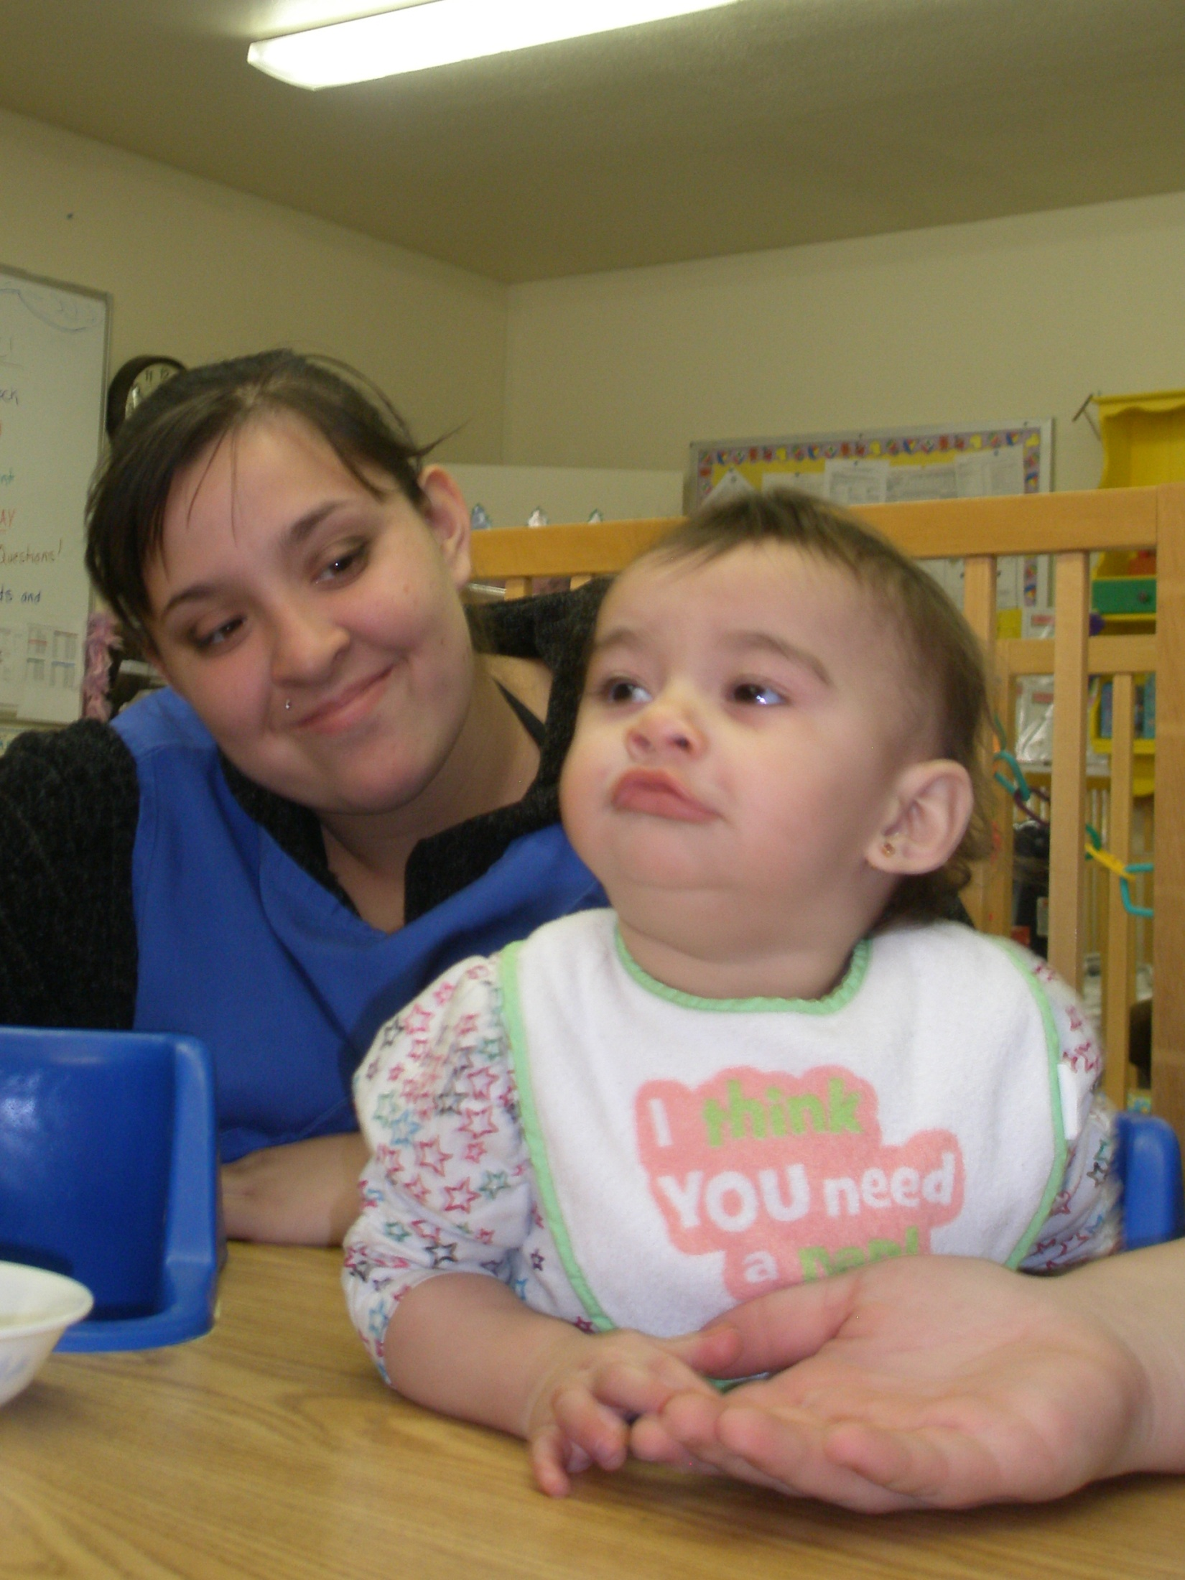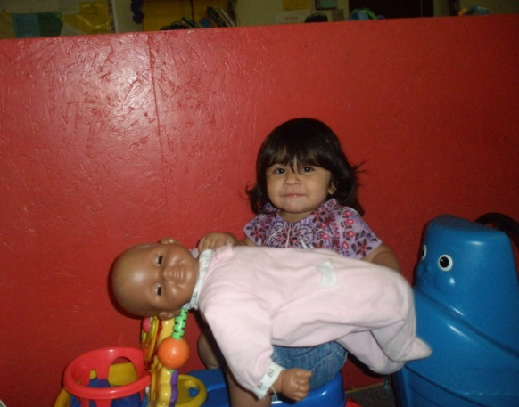
BELEN HIGH SCHOOL GRADS
The GRADS program at Belen High School, home of the BELEN EAGLES, has been in existence for 19 years. During this time, over 650 teen parents have participated in classes and/or case management. There are 30 students and 14 infants and toddlers enrolled this semester in the Belen HS GRADS program. The students attend both our high school and Infinity Alternative High School. Our graduation rate averages 94% or better of enrolled students. Without GRADS and our childcare center the majority of our students would not be able to stay in school. Support for the program comes from Staff, Administrators, our Superintendent, and our School Board. Also students receive assistance and information from WIC, CYFD, our School Based Health Center, Families First, Belen Health Department, and La Vida Felicidad.
Through the Childcare Center and Child Development classes, students are able to complete dual credit classes at UNM-VC. In one year students can complete 8 hours college credit in Early Childhood Multi-Ethnic courses. With this coursework and upon reaching 18 years of age, students are qualified to be hired full- or part-time as an employee in a licensed daycare. With the dual credit and class in the daycare, students are able to understand the value of the program as part of Career Pathways and our CTE programs.
A staff of 2 Educational Assistants works with the GRADS Instructor to coordinate the program. The GRADS Instructor is also the Daycare Director at Belen High School. This brings continuity to our program and provides a strong case management basis for the students.
